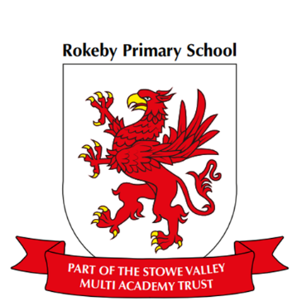

**Art** Learn about the illustrator Viviane Schwarz

To describe how they feel about others work

To communicate ideas and meaning

To use a range of processes to show ideas

To use a range of pens, pencils, pastels and charcoal

To talk about their work and explain it

**Computing Algorithms**

Understand what algorithms are and create and debug simple programs

Understand what algorithms are; how they are implemented as programs on digital devices; and that programs execute by following precise and unambiguous instructions

Create and debug simple programs

**Physical Education (PE) – Dance**

To change my shape and movement

To dance independently and with a partner

To move with a pretend object

To move my body to the beat

**Music**

Music express Water focus pitch

**RE**

What can we learn from sacred books?

**Design Technology ~** Design and make a treasure box/or make story boxes representing the different scenes.

To draw pictures with labels and text.

To use their knowledge of materials when designing.

To practise their skills before using them

To use photographs to present their finished design work

**Science-** **Materials**

Children can explore properties of materials they think most appropriate for a sea monster.

To compare the suitability and uses of everyday materials

To make relevant observations

To understand key features that make a fair test

To ask questions about what we see

To find out how solid materials can be changed

**Geography** Children can investigate and describe the climate and the physical features of treasure islands.

To discuss changes in weather and seasons from a chart

To draw simple maps and plans, sometimes with keys

To identify the main regions of the world-continents

To begin to use concepts of NSEW

**Maths**

In maths we will be looking at number, division, statistics, measurement focusing on Length and height and geometry and the properties of shapes.

**Year 2 Curriculum Overview- Spring 1**

**English**

This half term our topic will be Treasure Hunters with our class text ‘How to Find Gold’ by Viviane Schwarz. In English we will be using this text to talk confidently about a picture book and respond to it in a range of ways, exploring the story through a variety of learning including artwork, drama and roleplay. Engage in oral storytelling and bookmaking and write in role from more than one perspective.