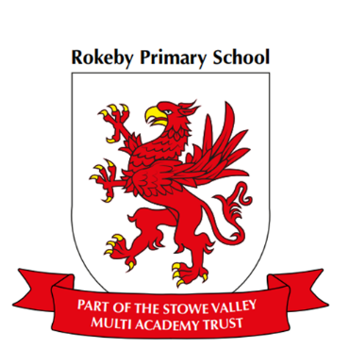

**Music**

Music express Animals focusing on pitch and tone.

**RE**

Who is a Muslim and what do they believe in?

**Design Technology ~ stain glass fish and moving snail airboat**

To describe what I want to do using pictures and words

To make lists of materials I will need

To use scissors or a cutting tools to cut out

To know how some moving objects work

To join materials together

**Science-** **Animals including humans**

To talk simply about what we see

To answer simple questions about what we see

To describe simple features with vocab (e.g. parts of the body, parts of an animals etc)

To sort data within given criteria

**Physical Education (PE) – Gymnastics moving and balancing**

Master basic movements such as three types of rolls

To use strong body tension

To roll forward from a crouch position

To balance independently and with a partner

To use different levels

**Computing**

Click and drag with a mouse

Switch on and shutdown a computer

Launch an application by double clicking.

**Geography** geographical vocabulary related to physical features, continents and oceans

To use simple blocked maps and plans

To describe places using their characteristics

To name places with similar characteristics (e.g seasides and towns)

**History** changes within living memory ~ change in national life

To identify old and new from pictures

To develop a simple awareness of the past

To use simple words and phrases to describe the past (after, before, between)

To answer questions about the past

**Maths**

In maths we will be looking at number and place value, addition and subtraction, including counting in multiples of 2, 3, 5 and 10 from 0 or 1.

**Year 1/2 Curriculum Overview- Autumn 1**

**English**

This half term our topic will be seaside explorers with our class text ‘The Snail and the Whale’ by Julia Donaldson. In English we will be drafting, writing and composing sentences orally. Sequencing sentences to form short narratives, looking at creating settings, characters and plots. Using this to write fiction and non-fiction texts.